Metacognitive Aspect of mathematics Problem Solving

Hwa Tee Yong and Lau Ngee Kiong
MARA University of Technology Malaysia

Abstract
If students are to excel on both the routine mathematics skills and the problem-solving skills, teachers must place emphasis on both the mathematical contents and the mathematical processes in the teaching and learning of mathematics. This paper presents the theoretical rationale and the importance of metacognition to the learning of mathematics. A project was conducted on students of around sixteen years of age and the findings indicated that students did employ the four phases of problem solving emphasized by George Polya. However, students fared better when they regulated their thinking process or employed metacognitive skills in the process of solving mathematics problems. This paper also suggests the strength of a mixed methodology in doing research by expanding an understanding from one methodology to another, and converging findings from different data sources.

Introduction

Twenty-first century mathematics education is about facing novel real-world problems, nurturing creative thinking skills and cultivating productive ways of learning. In attempting to innovate teaching and learning in order to prepare a new generation for the demands of this new era, many educators have discovered the value of metacognition.
Mathematics is always one of the difficult subjects for school students. Von Glaserfeld (1995) says:
[Educators] have noticed that many students were quite able to learn the necessary formulas and apply them to the limited range of textbook and test situations, but when faced with novel problems, they fell short and showed that they were far from having understood the relevant concepts and conceptual relations. (p. 20)
Educators attribute the lack of mastery of metacognitive skills of our students to be one of the factors contributing to this problematic situation. A study, employing a mixed methodology by using quantitative and qualitative approaches at the same time, was conducted to investigate the effect of metacognitive skills on the problem-solving ability of students. This paper not only sheds some light on the importance of metacognition in problem solving, also elucidates the strength of a mixed methodology.

Problem Solving
NCTM (1989) comments that:
Schools, as now organized, are a product of the industrial age. [M]inimum competencies in reading, writing and arithmetic were expected of all students, and more advanced academic training was reserved for the selected few. … The educational system of the industrial age does not meet the economic needs of today. (p. 3)

This is most probably the phenomenon which motivates the recent push for problem solving to be the centerpiece of mathematics curriculum. What is problem solving? Brownell (1942) says that:
... problem solving refers (a) only to perceptual and conceptual tasks, (b) the nature of which the subject by reason of original nature, of previous learning, or of organization of the task, is able to understand, but (c) for which at the time he knows no direct means of satisfaction. (d) The subject experiences perplexity in the problem situation, but he does not experience utter confusion. … problem solving becomes the process by which the subject extricates himself from his problem. (p. 416)
Literally, problem solving in mathematics is the process to find the solution to a problem when the method is not known to a problem-solver. Then the problem-solver has to use strategic skills to select the appropriate techniques for a solution. Pólya (1973) proposes the following four-stage problem-solving model:
Understanding the problem: This includes reading and clarifying a problem to identify the known, the unknown and the goal.
Devising a plan: This stage is the choosing of a strategy and devising a plan for a solution to the problem.
Carrying out: Once a problem-solver has a plan, the problem-solver will execute this plan and write out a solution.
Looking back: When a solution is ready, the problem-solver needs to check the legitimacy of this solution for the problem.
However, every problem-solver will notice that when tackling a problem, it is not just a simple top-down process of the above four stages.
In practice all the phases get mixed up and are carried out in parallel, each new discovery tends to modify the overall plan. (Pólya, 1973, p. xix)
The problem is often not completely understood until the problem-solver has tried and failed to arrive at a solution using different strategies. It is a series of going forward and backward among the four stages. Fernandez, Hadaway and Wilson (1994) provide a problem-solving model (Figure 1), which includes the managerial processes or what other educators such as Schoenfeld and Flavell called metacognition. This figure shows the non-linearity of problem solving which is actually experienced by problem-solvers. The clockwise and anti-clockwise nature of the cycle suggests that the problem-solving process can go top-down or bottom-up with reference to Pólya’s model. The managerial processes or metacognition will also trigger the problem solver to jump a stage or stages.

Figure 1: Framework emphasizing the dynamic and cyclic nature of problem-solving activity

Problem Understanding
posing the problem

Looking Managerial Making
Back Process a Plan

Carrying Out
the Plan

Metacognition

The concept of metacognition was first defined in the seventies. It seems that metacognition is a result of research on cognitive development, memory and reading. Many mathematics educators have shown great interest in this area as they realize that purely cognitive analyses of mathematical performance are inadequate for studying problem solving. Flavell (1976) defines metacognition as:
Metacognition refers to one’s knowledge concerning one’s own cognitive processes and products or anything related to them, e.g., the learning-relevant properties of information or data. … Metacognition refers, among other things, to the active monitoring and consequent regulation and orchestration of these processes in relation to the cognitive objects or data on which they bear, usually in the service of some concrete goal or objective. (p. 232)
He illustrates this term further by saying that
I am engaging in metacognition if I notice that I am having more trouble learning A than B; if it strikes me that I should double-check C before accepting it as a fact; if it occurs to me that I had better scrutinize each and every alternative in any multiple-choice type task situation before deciding which is the best one; if I become aware that I am not sure what the experimenter really wants me to do; if I sense that I had better make a note of D because I may forget it; if I think to ask someone about E to see if I have it right. (p. 232)
Brown (1987) says that what is of major interest is knowledge about one’s own cognition rather than cognition itself. He defines metacognition as those executive skills, which contribute to predicting, checking, monitoring, reality testing, and coordinating and controlling of deliberate attempts to learn or solve problems, and their use at the right time and in the right place.
Schoenfeld most probably has given the most comprehensive analysis of metacognition. According to Schoenfeld (1987, 1992), metacognition is thinking about our thinking and it comprises of the following three important aspects: knowledge about our own thought processes, control or self-regulation, and beliefs and intuition. The point according to Schoenfeld (1987) is that students should wisely divide their time among (a) understanding the problem, (b) planning, (c) making decisions on what to do, and (d) executing the decisions for a solution within the time frame. In the process of solving a problem, they should be monitoring and keeping track of the progress to a solution. When the decisions seem not to work, they should try other alternatives or make some adjustment. Once a decision is made to go for new alternatives, the work done should not be thrown away. There is always a risk that the curtailed efforts might have led to success.
Despite the apparent importance of metacognition in mathematical performance, it has not been studied systematically by mathematics educators. Several models of problem solving have been created, based on Pólya’s four-phase model, which assumes metacogntive processes only implicitly. Garofalo and Lester (1985) attribute this lack of attention to metacognition to the following three reasons:
Covert behaviour of any type is extremely difficult to observe and analyze.
Researchers who accept self-reports as legitimate data recognize that asking a person to verbalize information while performing a task may affect the cognitive process if the verbalized information would not otherwise be attended to.
Phenomena linked with metacognition have been regarded by many psychologists as too ill-defined for investigation.
Methodology
A study was conducted with one of its objectives to investigate the effect of metacognition on problem solving. A mixed methodology was adopted for this study that involved collecting and analyzing both quantitative and qualitative data. Researchers recognize that all methodologies have their strengths and weaknesses and feel that the strengths of one single methodology can complement the weaknesses of another methodology. In this study, the understanding gathered from quantitative analyses was expanded and elaborated through qualitative analyses. As such, this study was carried out in two parts.
Part I was predominantly quantitative. A sample of 412 students, selected randomly from a population of 2962 students, participated in this study. The instruments of this study consisted of a set of mathematics problems of 4 different levels of difficulty to be solved by the sample students for determining their problem-solving ability and a set of questionnaire to be completed by the same students for gathering students’ personal data and information related to the problem-solving process while answering mathematics problems. A factor analysis and a simple regression analysis were performed for identifying the problem-solving behavior of students.
Part II, predominantly qualitative, was carried out immediately after part I completed. Purposive sampling was used to select 18 students, taking into consideration issues like location of the school, interest of the mathematics teachers in this research and the mathematics ability of the students. A set of mathematics problems was posed to the selected students aiming to identify their metacognitive skills while solving these problems. The answering session for each student was video-recorded separately. The answer script and any rough work were collected back. After each video recording session, the researchers met, watched the tape and discussed issues that needed clarification from the student relating to problem-solving skills and problem-solving processes employed while solving the problems. Later, the tape was replayed to the student. The researchers simultaneously conducted an interview with this student to gather more information on these identified issues. These interviews were taped and the audiotapes were transcribed. Scheonfeld’s (1983) episode-parsing framework was adopted to analyze the data collected for the presence of metacognitive skills or executive skills.
Findings
The analysis performed on the scorings of the set of mathematics problems for part I of the study indicated that 75.7 % of the sample students were able to solve problems of the first level of difficulty. This percentage decreased drastically to 6.1 % for problems of the fourth level of difficulty (Table 1).
Table 1: Distribution of Students’ Achievement of different Levels of Difficulty
Level of Difficulty | Achievement |  |  |  |  |  | Total
Level of Difficulty | Low |  | Moderate |  | High
Level of Difficulty | N | % | N | % | N | % | N | %
Level 1 | 100 | 24.3 | 141 | 34.2 | 171 | 41.5 | 412 | 100
Level 2 | 220 | 53.4 | 121 | 29.4 | 71 | 17.2 | 412 | 100
Level 3 | 323 | 78.4 | 56 | 13.6 | 33 | 8.0 | 412 | 100
Level 4 | 387 | 93.9 | 18 | 4.4 | 7 | 1.7 | 412 | 100

A factor analysis was conducted on the responses for the questionnaire from part I of the study. The result shows that there were four factors with eigenvalues 1 and above, which account for 58.7 % (Table 2) of the sample variance. This finding coincides with the four stages of the problem-solving model proposed by Polya (1973) – “Understanding the problem”, “Devising a plan”, “Carrying out” and “Looking back”.
Table 2: Total Variance Explained of Factor Analysis
Factors |  | Rotation Sums of Squared Loadings
 |  | Eigenvalues | Percent of Variance | Cumulative Percent of Variance
1 | Read & Understand | 1.119 | 13.2 | 13.2
2 | Devising a Plan | 1.325 | 14.1 | 27.3
3 | Carry Out | 1.249 | 13.3 | 40.6
4 | Looking Back | 9.228 | 18.1 | 58.7
The variables considered for part I of this study were divided into three categories: problem-solving skills, basic mathematics skills and students’ characteristics. The value of R2 from a simple regression analysis was 0.536. This means that the variables for this study only accounted for 53.6 per cent of all the factors that influence the students’ achievement in mathematics problem solving. There were other variables such as metacognitive skills that needed to be considered.
Two case studies are presented to illustrate the findings from Part II of this study.
Case I: Simon was one of the students whose ability hardly met the first level of difficulty of mathematics problems. Figure 2 below represents the time-line graph of Simon working on a problem of the third level of difficulty. Simon went top-down for the four stages of problem solving proposed by Polya (1973). He spent little time clarifying the problem before choosing a wrong strategy and executing it for a solution. He never switched back to further clarify the problem and thought of an alternative strategy to solve the problem. In other words, there was no sign of metacognitive skills or the switching of stages of problem solving employed by Simon in the whole process of solving the problem. Coupled with his lack of mastery of basic mathematics skills, which are very essential for successful problem solving, he never got the correct solution.

Figure 2: Time-line Graph of Simon’s Problem-Solving Processes
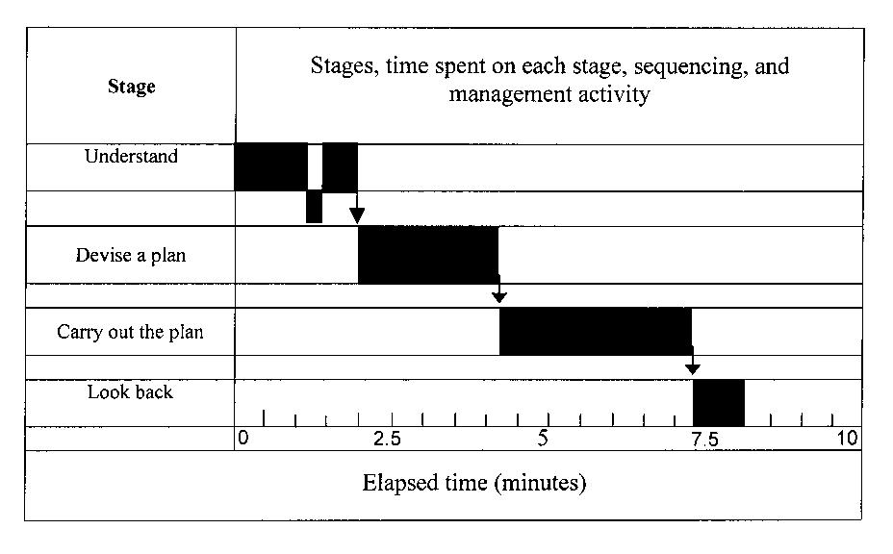

Case II: Angela was tipped to be one of the best students in mathematics from one of the participating schools. Figure 3 below represents the time-line graph of Angela working on the same problem given to Simon. Angela went through all the four stages of problem solving. After spending considerable time on reading and understanding the problem, she started planning for a solution. She recurred forward and backward the four stages of problem solving whenever she felt that she had not fully understand the problem, the chosen strategy was not correct or she was not confident with her solution. In other words, Angela employed some forms of metacognitive skills by constantly monitoring her moves while planning for a solution, carrying out her plan and checking her solution. It was this active deliberating process that brought her to her correct solution.
Figure 3: Time-line Graph of Angela’s Problem Solving Processes
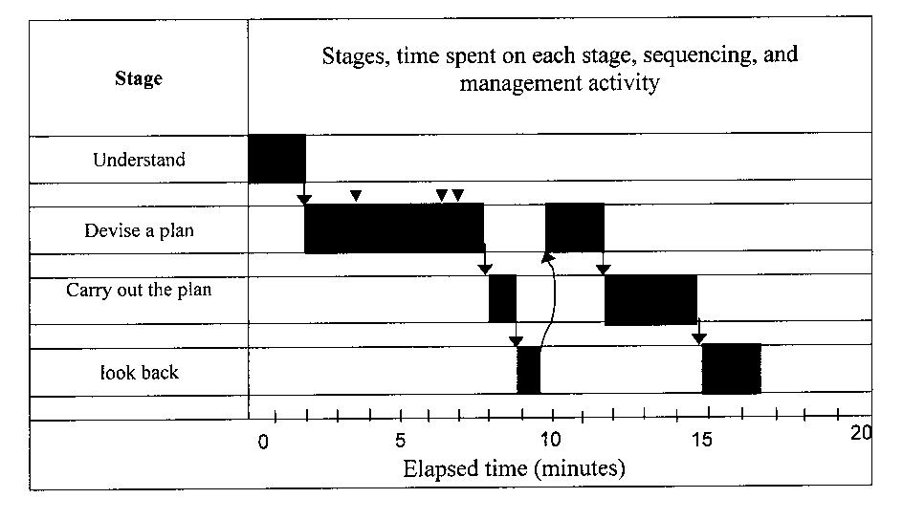
Discussions and Conclusions
The problem-solving ability of students for mathematics problems declined drastically from 75.7% for the first level of difficulty to 6.1% for the fourth level of difficulty. This phenomenon occurs because most of the problems given to students in schools are problems from the first level difficulty. These problems, like those at the back of each topic in traditional textbooks, should be termed as ‘exercises’, which function only to give students practice in certain skills, after they have learnt these skills (Polya, 1973, Borasi, 1986). They give students no training in calling to mind possible solutions and discriminating between them. The students could not perform for problems of the fourth level of difficulty because those problems not only demand the mastery of basic mathematics skills but also require higher cognitive processes or metacognition such as transformations or a series of formulation and reformulations to solve them (Duncker, 1945; Lakatos, 1976).
No matter how students fared, the result of the factor analysis indicated that they did employ the four stages of problem solving proposed by Polya (1973). However, the mere employment of problem-solving skills is not enough to bring about success in solving mathematics problems of students. Both the value of 0.536 for R2 from a simple regression analysis and the problem-solving process exhibited by Simon support this. There are three key features that caused the failure in obtaining a solution by Simon, coinciding with those proposed by Scheonfeld (1985):
Simon’s obstinate commitment to the one and wrong approach.
He never questioned his achievement in the process of tackling the problem.
Alternative approaches were never proposed.
Simon squeezed through his strategy together with the wrong mathematics skills for a solution, which he was not sure of and did not bother about being right or wrong. The years of schooling have ‘engendered a belief that school mathematics tasks need not make sense’ (Goos et al., 2000) in him.
The case of Angela illustrates the importance of metacognition in bringing about success in solving mathematics problems. This finding is in line with the conclusion by Scheonfeld (1985) that a good problem-solver constantly questions his or her achievement. He or she generates a number of possible candidates to the method of solution, but is not seduced by them. By making careful moves such as pursuing productive leads and abandoning fruitless paths, he or she solves the problem successfully.

Reference
Borasi, R. (1986). On the nature What is an eigenvalue of problems. Educational Studies in Mathematics. pp. 125 - 141.

Brown, A. L. (1978). Knowing when, where and how to remember: A problem of metacognition. In R. Glaser (Ed.), Advances in Instructional Psychology (Vol. 1). Hillsdale, NJ: Lawrence Erlbaum Associates.

Brownell, W. A. (1942). “Problem Solving”, The Psychology of Learning, chap. xii. Forty-first Yearbook of the National Society for the Study of Education, Part II. Chicago: University of Chicago Press.

Duncker, K. (1945). On Problem Solving. Psychological Monographs 1945, 58, 5, whole no. 270.

Fernandez, M. L., Hadaway, N. & Wilson, J. W. (1994). Problem solving: Managing it all. The Mathematics Teacher, Vol. 87, No. 3, pp. 195 - 199.

Flavell, J. H. (1976). Metacognitive aspects of problem solving. In L. B. Resnick (Ed.), The Nature of Intelligence. Hillsdale NJ: Lawrence Erlbaum Associates.

Garofalo, J. & Lester, F. K. (1985). Metacognition, Cognitive Monitoring and Mathematical Performance. Journal for Research in Mathematics Education, Vol. 16, No. 3, pp. 163 - 176.
Goos, M. (2000). Metacognition in context: A study of collaborative metacognitive activity in a classroom community of mathematical inquiry, Unpublished doctoral thesis. The University of Queensland, Brisbane.

Lakatos, I. (1976). Proofs and Refutations: The Logic of Mathematical Discovery. Cambridge: Cambridge University Press.

National Council of Teachers of mathematics, (1989). Curriculum and evaluation standards for school mathematics. Reston, VA: NCTM.

Polya G.(1973): How To Solve It. Princeton: Princeton University Press.

Schoenfeld, A. H. (1983). Episodes and executive decisions in mathematical problem solving. In R. Lesh and M. Landau (Eds.), Acquisition of Mathematics Concepts and Processes, pp. 345 - 395. NY: Academic Press.

Schoenfeld, A. H. (1985). Mathematical Problem Solving. San Diego: Academic Press Inc.

Schoenfeld, A. H. (1987). What’s all the fuss about metacognition? Ch. 8 in A. H. Schoenfeld (Ed.), Cognitive Science and Mathematics Education. Hillsdale, NJ: Erlbaum.

Schoenfeld A. H. (1992): Learning to Think Mathematically: Problem Solving, Metacognition and Sense Making in Mathematics. In D. Grouws (Ed.), Handbook of Research on Mathematics Teaching and Learning, pp. 334 - 370. New York: Macmillan.

Von Glasersfeld, E. (1995). Radical Constructivism: A Way of Knowing and Learning. London: Falmer Press.

