Part A:
1)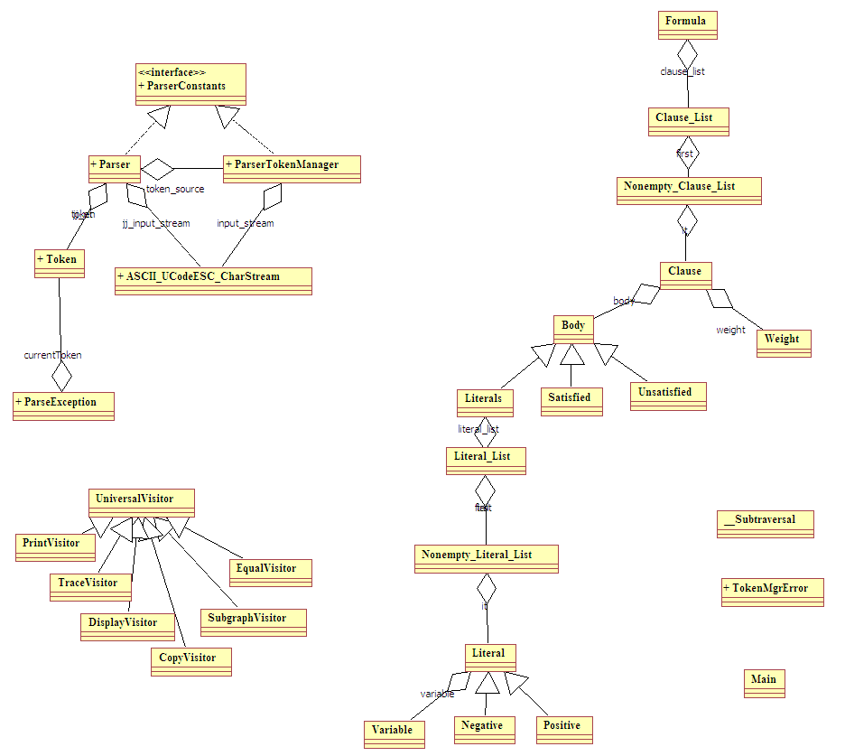
2) The program Counts the number of variable occurrences and sums the weights of all clauses.

Part B.1:
Code:
===============================================================
Program.cd

import edu.neu.ccs.demeter.dj.*;
import java.util.*;

Formula = List(Clause) Assignment EOF.
Clause = Weight ":" Body.
Body : Satisfied | Unsatisfied | Literals.
Literals = List(Literal).
Literal : Positive | Negative common Variable.
Positive = .
Negative = "not".
Variable = Ident.
Satisfied = "sat".
Unsatisfied = "unsat".
Assignment = "Assignment:" List(Variable).
Weight = <v> float.
visitors
AssignmentVisitor = <v> Vector.
SatVisitor = <v> Vector.

endvisitors
Main =.
List(S) ~ S {S}.

===============================================================
Program.beh

Main {
{{
static ClassGraph cg;
public static void main(String args[]) throws Exception {
Formula csp1 = Formula.parse(System.in);

AssignmentVisitor av = new AssignmentVisitor();
av.start();
csp1.collectAssignment(av);
Vector a = av.get_return_val();
System.out.println("True Variables are:"+a);

SatVisitor sv = new SatVisitor(a);
sv.start();
csp1.sat(sv);
float w = sv.get_return_val();
System.out.println("Weight: "+w);
}

}}
}

Formula {
void print() to * (PrintVisitor);

traversal collectAssignment(AssignmentVisitor){
via Assignment to Variable;
}
traversal sat(SatVisitor){
via Clause to {Body,Weight,Literal,Variable};
}
}

AssignmentVisitor{
start (@ v = new Vector(); @)
before Variable (@ v.add(host.get_ident().toString()); @)
return Vector (@ v @)
}

SatVisitor{
(@
float weight;
float w;
int sat;
@)
start (@@)
before Clause(@ sat = 0; @)
after Clause (@ if (sat==1) weight+=w; @)
before Weight(@ w = host.get_v(); @)
before Literal(@
String varName = host.get_variable().get_ident().toString();
if (host instanceof Positive){
if (v.contains(varName)){
sat = 1;
}
}else{
if (!v.contains(varName)){
sat = 1;
}
}
@)
around Body (@
if (host instanceof Literals){
subtraversal.apply();
}else if ( host instanceof Satisfied){
sat = 1;
}else{
sat = 0;
}
@)
return float (@ weight @)
}
===============================================================Program.prj
// The standard prj file generated with demeterj new
===============================================================
(Please note that it is also possible to shortcut our evaluation of the satisfiability of a clause when we encounter a true variable.)

Test Case 1:
(Note that the in the assignment we give only a list of true literal.)
Input:
23 : A not B C D
45 : not A not B
46 : sat
Assignment: B

Output:
C:\csg260\HW1\sat>demeterj test
DemeterJ version 0.8.6
Copyright (c) 2003 Northeastern University
Reading project file program.prj...
Running the test...
True Variables are:[B]
Weight: 91.0

Test Case 2:
Input:
23 : A not B C D
45 : not A not B
46 : sat
Assignment: A B

Output:
C:\csg260\HW1\sat>demeterj test
DemeterJ version 0.8.6
Copyright (c) 2003 Northeastern University
Reading project file program.prj...
Running the test...
True Variables are:[A, B]
Weight: 69.0

The maximum assignment with is also a better assignment for the given problem is:
A = false, B=C=true
The weight is: 107

Part B.2:
Code:
===============================================================
Program.cd

import edu.neu.ccs.demeter.dj.*;
import java.util.*;

Formula = List(Clause) Assignment EOF.
Clause = Weight ":" Body.
Body : Satisfied | Unsatisfied | Literals.
Literals = List(Literal).
Literal : Positive | Negative common Variable.
Positive = .
Negative = "not".
Variable = Ident.
Satisfied = "sat".
Unsatisfied = "unsat".
Assignment = "Assignment:" List(Variable).
Weight = <v> float.
visitors
AssignmentVisitor = <v> Vector.
SatVisitor = <v> Vector.

endvisitors
Main =.
List(S) ~ S {S}.

===============================================================
Program.beh
Main {
{{
static ClassGraph cg;
public static void main(String args[]) throws Exception {
Formula csp1 = Formula.parse(System.in);

AssignmentVisitor av = new AssignmentVisitor();
av.start();
csp1.collectAssignment(av);
Vector a = av.get_return_val();
System.out.println("True Variables are:"+a);

SatVisitor sv = new SatVisitor(a);
sv.start();
csp1.sat(sv);
float w = sv.get_return_val();
System.out.println("Weight: "+w);
}

}}
}

Formula {
void print() to * (PrintVisitor);

traversal collectAssignment(AssignmentVisitor){
via Assignment to Variable;
}
traversal sat(SatVisitor){
via Clause to {Body,Weight,Literal,Variable};
}
}

AssignmentVisitor{
start (@ v = new Vector(); @)
before Variable (@ v.add(host.get_ident().toString()); @)
return Vector (@ v @)
}

SatVisitor{
(@
float weight;
float w;
int sat;
@)
start (@@)
before Clause(@ sat = 0; @)
after Clause (@ if (sat==1) weight+=w; @)
before Weight(@ w = host.get_v(); @)
before Literal(@
String varName = host.get_variable().get_ident().toString();
if (host instanceof Positive){
if (v.contains(varName)){
sat += 1;
}
}else{
if (!v.contains(varName)){
sat += 1;
}
}
@)
around Body (@if (host instanceof Literals){
subtraversal.apply();
}else if ( host instanceof Satisfied){
sat = 1;
}else{
sat = 0;
}
@)
return float (@ weight @)
}

===============================================================Program.prj
// The standard prj file generated with demeterj new
===============================================================
(Please note that it is also possible to shortcut our evaluation of the satisfiability of a clause when we encounter two variables=1.)

Test Case 1:
(Note that the in the assignment we give only a list of variables whose value is 1.)
Input:
23 : X1 not X2 X3
45 : X1 X2 X4
46 : X1 X3 X4
100: X2 X3 X4
Assignment: X4

Output:
C:\csg260\HW1\oneInThree>demeterj test
DemeterJ version 0.8.6
Copyright (c) 2003 Northeastern University
Reading project file program.prj...
Running the test...
True Variables are:[X4]
Weight: 214.0

Test Case 2:
Input:
23 : X1 not X2 X3
45 : X1 X2 X4
46 : X1 X3 X4
100: X2 X3 X4
Assignment: X1 X2

Output:
C:\csg260\HW1\oneInThree>demeterj test
DemeterJ version 0.8.6
Copyright (c) 2003 Northeastern University
Reading project file program.prj...
Running the test...
True Variables are:[X1, X2]
Weight: 169.0

The maximum assignment with is also a better assignment for the given problem is:
X4=1, X1=X2=X3=0
The weight is 140

Part B.3:
Here it is much easier to find the differences rather than the duplications. There are two differences in the program.beh file.
(Part A) Sat | (Part B) One In Three
before Literal(@  String varName = host.get_variable().get_ident().toString();  if (host instanceof Positive){  if (v.contains(varName)){  sat = 1;  }  }else{  if (!v.contains(varName)){  sat = 1;  }  }  @) | before Literal(@  String varName = host.get_variable().get_ident().toString();  if (host instanceof Positive){  if (v.contains(varName)){  sat += 1;  }  }else{  if (!v.contains(varName)){  sat += 1;  }  }  @)
The difference is essentially are the two underlined “+” signs that exists only in part B.

Part B.4:
Code:
===============================================================
Program.cd

import edu.neu.ccs.demeter.dj.*;

Instance = Polynomial Assignment.
Polynomial = List(Coefficient).
Coefficient = <a> float.
Assignment = "Assignment:" <x> float.
visitors
AssignmentVisitor = .
EvaluationVisitor = <x> float.
endvisitors
Main =.
List(S) ~ S {S}.

===============================================================
Program.beh

Main {
{{
static ClassGraph cg;
public static void main(String args[]) throws Exception {
Instance p = Instance.parse(System.in);

AssignmentVisitor av = new AssignmentVisitor();
p.collectAssignment(av);
float x = av.get_return_val();
System.out.println("x = " + x);

EvaluationVisitor ev = new EvaluationVisitor(x);
ev.start();
p.eval(ev);
float s = ev.get_return_val();
System.out.println("p: "+s);
}

}}
}

Instance {
void print() to * (PrintVisitor);

traversal collectAssignment(AssignmentVisitor){
to Assignment;
}
traversal eval(EvaluationVisitor){
to Coefficient;
}
}

AssignmentVisitor{
(@ float x; @)
before Assignment (@ x = host.get_x(); @)
return float (@ x @)
}

EvaluationVisitor{
(@float s;@)
start(@s=0;@)
before Coefficient(@s = s*x+host.get_a();@)
return float (@ s @)
}
===============================================================Program.prj
// The standard prj file generated with demeterj new
===============================================================

Test Case 1:
(Note that the input is a list of coefficients)

Input:
1 2 3 0 4
Assignment: 2

Output:
C:\csg260\HW1\Polynomial>demeterj test
DemeterJ version 0.8.6
Copyright (c) 2003 Northeastern University
Reading project file program.prj...
Running the test...
x = 2.0
p: 48.0

Test Case 2:
Input:
1 2 3 4
Assignment: 2

Output:
C:\csg260\HW1\Polynomial>demeterj test
DemeterJ version 0.8.6
Copyright (c) 2003 Northeastern University
Reading project file program.prj...
Running the test...
x = 2.0
p: 26.0

Part B.5:

Traditionally programs are represented in the form of a stream of characters. Such representation makes the structure program less obvious. Therefore, it is not suitable when we perform operations that rely upon the structure of the program.
Changing the program representation from stream of characters to syntax tree is a frequent task. This task is typically performed in two phases: Lexical analysis and Parsing.
In lexical analysis, the stream of characters is translated into a stream of tokens. For a lexical analyzer to work it needs a description of tokens. Regular Expressions are used to describe tokens.
In Parsing, the stream of tokens is translated into a syntax tree. For a parser to work it needs a description of the syntax tree. A Context Free Grammar (CFG) or one of its subclasses (e.g. LL(k), LR, …) is used to describe the tree.
There are two classes of parsers: Top-Down and Bottom-Up. Examples of Top-Down parsers include Recursive descend parsers and predictive parsers. Top-Down parsers are suitable for parsing LL(k) grammars.
The following graph describes relationships among grammar classes.

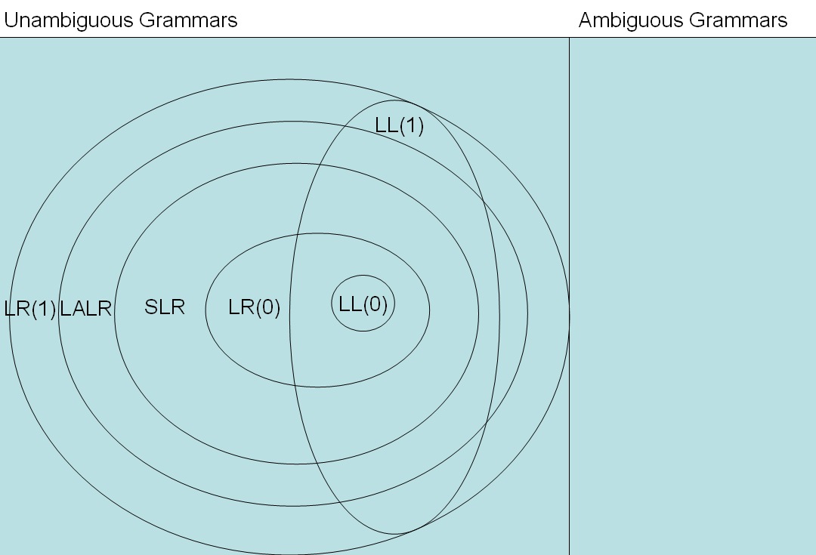
(Source: http://www.cs.princeton.edu/courses/archive/spr05/cos320/notes/7-parsing-error.ppt#338,81,Grammar Relationships)

Part C:

UNKNOWN1 = PersonalInfo

UNKNOWN2 = Address

UNKNOWN3 = City

UNKNOWN4 = Date

UNKNOWN5 = bad way

UNKNOWN6 = personalInfo

UNKNOWN7 = address

UNKNOWN8 = name

UNKNOWN9 = buildClassGraph

UNKNOWN10 = DJ

UNKNOWN11 = The class graph is

UNKNOWN12 = Employee

UNKNOWN13 = Employee

UNKNOWN14 = personalInfo_

UNKNOWN15 = d

UNKNOWN16 = a

UNKNOWN17 = fetch

UNKNOWN18 = Boston

UNKNOWN19 = Boston

