CSU670 Project Description
Graph Visualization Plug-in for Eclipse

By
Karl Lieberherr and Jun Gong
Fall 2003
Version 1.5

Introduction
- For this project, you are asked to implement two editors for an Eclipse plug-in. The two editors involved are the Class Diagram editor for drawing UML class diagrams and the Selector Language editor for choosing subgraphs in the class diagram. Your tool visualizes subgraphs according to the input entered through the Selector Language editor, and it highlight the subgraphs selected in the class diagram editor. Your final work may look like the pictures shown below: In Figure 1 is a picture of the interface of the Selector Language editor (SLE) and in Figure 2 is a picture of the class diagram editor (CDE). In Figure 1 is an extended strategy language that also allows in addition the definition of node sets. Your first task in the project is to come up with a class dictionary for this extended language. In Figure 1 we define a strategy s1: “from SimpleType via SchemaItem to Attribute”. And in Figure 2 we have selected this strategy (notice the properties on the Properties bar on the right in Figure 2) and the selected subgraph is highlighted in red. The user of your tool first draws a UML class diagram using CDE, then she uses SLE to define various subgraphs and then she uses CDE to name one of the subgraphs and to highlight it in red.
- The above description serves as a minimal requirements document that will be refined during the software development phase.
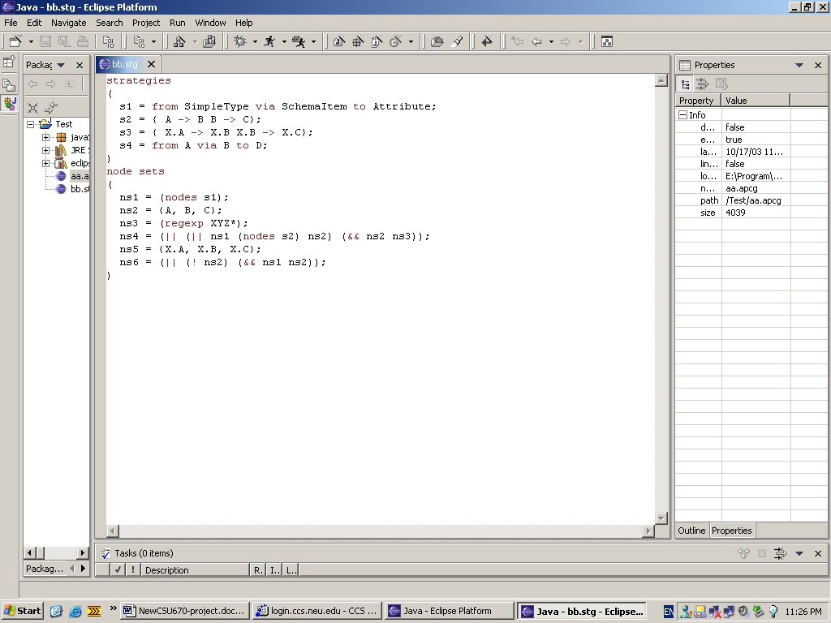
Figure 1: Selector Language Editor
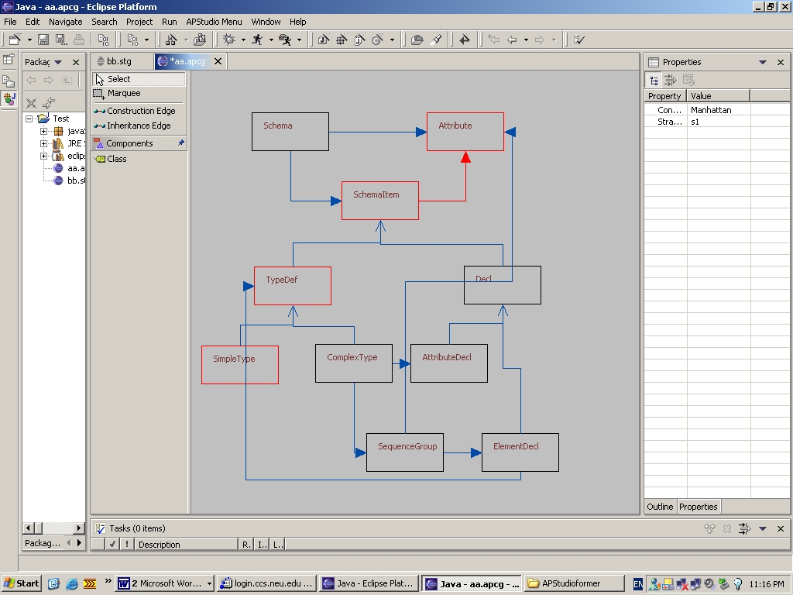
Figure 2: Class Diagram Editor
- You may either entirely write your own plug-in or use the half-implemented class diagram plug-in which will be provided to you on the course web page.
- This document contains the description of the project, the development enviroment, the background knowledge you need to know, and the resources available.

Environment Setup
- To complete the above work, you need to download and install the Eclipse IDE, Eclipse Graphical Editing Framework tool (GEF), DJ, and DemeterJ:
- Eclipse 2.1.1
For writing the program, testing the plug-in, and almost everything else.

http://www.eclipse.org/downloads/index.php
and
http://www.ccs.neu.edu/home/lieber/courses/csu670/f03/materials/eclipse/V21_ExerciseMast.pdf
and the zip file in the same directory. This is an excellent document for learning Eclipse.
- The Graphical Editing Framework (GEF), and Draw2D Tools for Eclipse GUI development.
http://download.eclipse.org/tools/gef/downloads/
- DJ 0.8.6
For class graph traversal and highlighting. Note that DJ has a constructor for class ClassGraph that takes as argument a Traversal-object. You need to use this constructor to turn a traversal graph into a class graph.

http://www.ccs.neu.edu/home/lieber/courses/csu670/f03/project/code-provided/rt.jar

- DemeterJ 0.8.6
For parsing the generalized traversal language. http://www.ccs.neu.edu/research/demeter/software/docs/install.html
Eclipse 2.1.1 comes as a zip file. To install it, you simply extract it into a folder, suppose C:\Eclipse. And after that, you should extract the GEF zip package into that Eclipse installation folder. This will automatically install GEF and Draw2D plugins into their proper directory. Save the DJ package at a convenient place for later use.
- Import external Java archives
After the creation of a new project, right click the root folder of that project -> select properties in the popup menu -> select Java Build Path page -> press Add External JARs -> find the jar file you are planning to add and press OK.
- Import existing Eclipse project
Click File -> Import... -> Existing Project into Workspace -> Next -> Select correct directory -> Finish.
- Be sure to add GEF, Draw2D, and DJ package into your project class path.
- An extended version DJ package is provided to you, which is capable of parsing the generalized Selector Language. Details of the usage of this package will be discussed later in Files and Classes section.
Figure 2: Class Diagram Editor

Plug-in Overview
- The final plugin you turn in should have the following functionalities:
- Provide a Graphical Editor for drawing UML class diagrams, which is already implemented for you. But you may choose to improve it.
- Create Java source files corresponding to the UML class diagram. This is also implemented.
- Provide a Selector Language Editor, which is simply an extension to the text editor but has the capability of highlighting the Selector Language Keywords. Keywords are strings (between “ and “) in your Selector Language class dictionary.
- Contribute a button to the tool bar as part of your Selector Language Editor. When it is pressed, parse the content of your Selector Language Editor by using the provided SelectorLanguage class in the DJ package. Save the selector information.
- Compute the TraversalGraph according to the strategy that the user has specified.
- Highlight the edges and nodes selected by the TraversalGraph.

- Fortunately, the provided plugin already accomplishes the first two jobs. What you need to do is to write a Selector Language class dictionary so that you may accept and parse the selector language input, traversing the diagram accordingly and highlight the selected nodes and edges in the diagram. The whole process is sketched below:

Selector Language
Write Selector Language
TraversalGraph
User
Class Graph
Construct
Class Diagram
Draw Class Diagram
Update Class
Diagram
Generate Source code

Java Source code

Eclipse Plug-in Development and GEF tool
- http://www.eclipse.org/pde/index.html is a good place to start learning about Eclipse PDE (Plugin Development Environment). The PDE project provides a number of views and editors that make it easier to build plug-ins for Eclipse. Using the PDE, you can create your plug-in manifest file (plugin.xml), specify your plug-in runtime and other required plug-ins, define extension points, including their specific markup, associated XML Schema files with the extension point markup so extensions can be validated, create extensions to other plug-in extension points, etc. The PDE makes integrating plug-ins easy and fun.
- SWT (The Standard Widget Toolkit) carries a set of components that PDE provides, with which you can easily construct your Eclipse graphical user interface. And JFace provides a registry mechanism on top of SWT for image and font resource management.
- The GEF (Graphical Editing Framework) allows developers to take an existing application model and easily create a rich graphical editor. GEF is very suitable for writing editors like UML diagram editors. Please read the following GEF tutorial: http://www-106.ibm.com/developerworks/opensource/library/os-gef/, it’s truly a good place to start from for beginners.
- After you’ve learned something about all of the above tools, you should read the tutorial on how to write an Eclipse plugin, which you can find at Eclipse help menu -> help content.

DJ traversal
- You can easily highlight a class graph by creating a TraversalGraph object of that class graph. After the TraversalGraph is created, turn it into a ClassGraph. You may retrieve all the edges and nodes within that ClassGraph by simply calling the member methods getEdgeSets() and getNodeSets().
- Highlight those nodes and edges on your class diagram by updating the properties of corresponding models (either Connector or ClassDiagramModel).

Files and Classes
- After you download, extract, and import the project package, you can find that there is a class named CSU670Helper. And within that class, two method stubs have already been created for you. Your job is to fill in the proper behaviors, so that it may complete the expected functionalities.
- package APStudio.models
class BasicSubpart
Super class of class Connector and class ClassDiagramModel.

BasicSubpart
ClassDiagramModel
Connector

Some useful methods of this class are:

public Vector getOutputs()
// get all the outgoing edges of the class this model represents.

- package APStudio.models
class Connector
The model of an edge in the class diagram.

Some useful methods of this class are:

public boolean getValue()
// Get the color property of this edge. If false, its color is blue, and if true, red.

public boolean setValue(boolean)
// Set the color property of this edge. If false, its color is blue, and if true, red.

- package APStudio.models
public class ConstructionConnector extends Connector
// The model for a has-a edge (construction edge).

- package APStudio.models
public class InheritanceConnector extends Connector
// The model for an is-a edge (inheritance edge).

- package APStudio.models
class ClassDiagramModel
// The model of a class in the class diagram.

Some useful methods of this class are:

public boolean isSelected()
// Get the color property of this class. If false, its color is blue, and if true, red.

public void setSelected(boolean)
// Set the color property of this class.

- class APStudio.CSU670Helper
public static ClassGraph createClassGraph(List nodeList)
// Return a class graph (from the DJ library) constructed according to the node list passed in.

nodeList: a list of instances of ClassDiagramModel. Each item in this list represents a class in the class diagram.
Returns the ClassGraph constructed.

- class APStudio.CSU670Helper
public static String highlightTraversal
(ClassGraph cg, List nodeList,
String strategy, boolean is_nodeset)
// Highlight nodes and edges selected by the strategy in the class diagram.

cg: the class graph of current class diagram, should be used to create the Traversal object.
nodeList: a list of instances of ClassDiagramModel. Each item in this list represents a class in the class diagram.
Strategy: DJ strategy. Used in creating the Traversal object.
is_nodeset: Boolean indication of whether only nodes should be highlighted. (Please note that inheritance edges are not included in the returned set of edges when calling method Traversal.getEdgeSets() )
Returns the error message if any, or empty string.

- class APStudio.CSU670Helper
public static String RefreshStrategy(String name)
// Returns the strategy according to the name the user specified.

name: The name of the StrategyDef or NodeSubsetSpec.

Please note that the name of a NodeSubsetSpec may refer to another NodeSubsetSpec. So you need to loop until you get the final StrategyDef they all refer to. For example:
s1 = from A to B
n1 = (nodes s1)
n2 = n1
So the call RefreshStrategy(“n2”) should return “from A to B”.

Note by Karl: RefreshStrategy is not general enough. How can this part of the design be improved?

- class APStudio.CSU670Helper
public static boolean isNodeSet(String name)
// Returns whether the name represents a StrategyDef or a NodeSubsetSpec.
// true if it’s a name of a NodeSubsetSpec, and false if it’s a name of a StrategyDef.

Suppose the same input as above:
isNodeSet(s1) will return false.
isNodeSet(n1) will return true.

- package edu.neu.ccs.demeter.aplib.sg
public class SelectorLanguage
// The class generated by DemeterJ representing the input Selector Language.

Some useful member methods of this class are:
public static SelectorLanguage parse(String arg)
// parse the input string into a SelectorLanguage object.

arg: the Selector Language that needs to be parsed.
Returns a parsed SelectorLanguage object.

public List getLists()
// Returns a list of two HashMaps.
// Both of the HashMaps are String to String Maps.
// The first HashMap maps the name of a StrategyDef to the corresponding content.
// The second HashMap maps the name of a NodeSubSetSpec to the Content.

Returns a list of two HashMaps. getList()[0] is the Map from name to content of Strategy, and getList()[1] is the Map from name to content of NodeSelectionSpecification.

For example:
List: [ListItem0, ListItem1]
ListItem0: { “s1” -> “from A via B to C”
“s2” -> “from A bypassing -> A, x, B to *”}
ListItem1: { “n1” -> “s1”
//n1 is the node set of strategy s1
“n2” -> “n1”}
//n2 is the node set equals to n1
(Note that currently the plug-in only supports these two types of NodeSubsetSpec.)
Note by Karl: how can this design be improved and generalized?

Usage of the class diagram editor
- Create an empty Eclipse project.
- Create a new file with the file extension named apcg, e.g. aaa.agcg, jack.apcg, ...
- Double clicking the newly created agcg file will open the class diagram editor.
- Pick the class tool from the palette, click and drag a new class to the canvas, click the name of the class to change it. Also, you may adjust the size and location properties of this class in the property page.
- Pick the Construction Edge tool or the Inheritance Edge tool to draw the edges between classes. You may connect two classes at one of the four anchors of each class.

Class
Anchor
Anchor
Anchor
Anchor

- Click the highlight traversal button to highlight the selected nodes and edges.

Testing
- If there’s time, an automatic testing tool written in JUnit will be provided. Otherwise, you should test your project with sufficiently many test cases to ensure that it behaves correctly according to the program specifications.

Suggested Project Phases
- This section gives our suggested working phases for implementing the visualization plug-in. Following these phases is highly recommended.
- Phase 1: Define the class dictionary of the selector language that selects nodes and edges in the class graph. You need to add the Node Selection Language definition to the current strategy class dictionary in the AP Library. You also need to design a growth plan for this class dictionary that describes in which order you plan to add the features of the selector language to your Eclipse plug-in. Start with strategies and with node sets determined by strategies. Start with class dictionary in the sg subdirectory of the AP Library at
http://www.ccs.neu.edu/research/demeter/software/docs/src/aplib/sg/sg.cd .
- Phase 2: Read documents about PDE, SWT, GEF, Jface and anything else you think may be helpful. Do lab exercise 1,2,8,18. The lab exercises are in a subdirectory of the course directory:
http://www.ccs.neu.edu/home/lieber/courses/csu670/f03/materials/eclipse/V21_ExerciseMast.pdf
- The same directory contains file V21_Lab_Import_Master.zip that contains the source files for the exercises. Don’t start Phase 3 until you can understand the provided Java source code and the relationships between the packages and source files. If you are writing the whole project from the beginning, implement and test the UML diagram editor in this phase.
- Phase 3: Add your Selector Language editor to the plug-in. You should use the extended DJ package provided to parse the input instead of your own extended class dictionary. In other words, put your class dictionary for step 1 aside after you’ve turned it in.
- Phase 4: Implement the DJ traversal part of this plugin. After the completion of this phase, you should be able to construct the class graph object of a given class diagram, get the traversal according to the information you collected in the last step, and find out the edge set and node set of a traversal.
- Phase 5: Highlight the node and edge set in the class diagram by updating the models of corresponding Connections. With the knowledge you obtained from earlier phases, you should be able to complete this quite easily.
- For this project breakdown, Phase 2 is the biggest step, as you need to understand or implement a relatively very complex diagram editor. So you should attempt to finish this part with 2 weeks left till the deadline. Don't forget to save some time for the write-up, as it may take longer than anticipated.
- After each phase, you should save the state of the project to some other directory. This allows you to roll back to the previous phase if you happen to take the wrong approach in solving the next phase. Not only that, if your program does not compile and you need to submit it, then you can submit the previous phase of the project. This is usually a good practice for big projects. Read chapter 17 of TPP. Following the text book, The Pragmatic Programmer, you need to use a source code management tool such as CVS.

Submission
- The whole project is broken down into four parts, so you are required to turn in each part separately to ensure your proper progress.
- Firstly, turn in your extended class dictionary and growth plan on or before Oct.27 (midnight). Your work will be used to parse some nontrivial inputs, and will be graded based on how many correct inputs it can parse. Your growth plan will also be graded.
- Secondly, turn in your plug-in which has a syntax sensitive Selector Language editor before Nov.12. Because for this part strategy highlighting is not available, you may show your work by printing the Selector Language sentence to some file.
- Thirdly, before Nov.26, please turn in your completed plug-in.
- Finally, complete and turn in your project report before the final exam.

Anything else
- Some example inputs. You should come up with the Selector Language Class Dictionary so that it can parse these samples.
strategies
( // there must be at least one strategy
s1 = from A via B to C;
s2 = { A -> B B -> C}; // strategy graph notation = from A via B to C
s2 = { X.A -> X.B X.B -> X.C};
)
node sets
( // zero or more node sets
ns1 = (nodes s1); // all nodes in the scope of strategy s1.
ns2 = {A, B, C}; // the enumerated nodes: A, B, C.
ns3 = (regexp XYZ*); // the nodes whose names start with XYZ
ns4 = (|| (|| ns1 (nodes s2) ns2) (&& ns2 ns3)); // || is set union, && is set intersection
ns5 = {X.A, X.B, X.C}; // the enumerated nodes in package X
ns6 = (|| (! ns2) (&& ns1 ns2)); // ! is complement
)
- Your extended class dictionary should starts with:
SelectorLanguage = "strategies" StrategyLanguage "node" "sets" NodeSubsetLanguage.
StrategyLanguage = NPList(StrategyDef).
NodeSubsetLanguage = PList(NodeSubsetSpec).
......

